**Class Exercise – 1.1**

**Name: Ashlyn Cooper**

**Clemson/Assignment ID: PROJ1**

**Submission**: Save this Word document with your answers as a PDF file and upload the PDF file to Canvas.

**Use this file structure to answer the questions below**

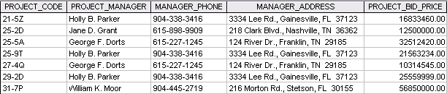

1. **How many records does the file contain? How many fields are there per record?**
   1. Records: 7
   2. Fields per Record: 5
2. **What problem would you encounter if you wanted to produce a listing by city? How would you solve this problem by altering the file structure?**
   1. The data for the city is embedded within the address field and is part of a whole address and not just the city data. You could solve this problem by adding a new field to the file structure that contains the city data on its own.
3. **If you wanted to produce a listing of the file contents by last name, area code, city, state, or zip code, how would you alter the file structure?**
   1. I would add/split fields that contain the specific data that you would want to list the file contents by. So, I would make sure there is a last name field, area code field, city field, state field, and zip code field.
4. **What data redundancies do you detect? How could those redundancies lead to anomalies?**
   1. The same data for several project managers is duplicated across multiple records. The same project managers are associated with multiple different project codes, so the data associated with the specific project manager is duplicated across the records for different project codes. This could lead to anomalies if the data is entered correctly in some fields but incorrectly in others, leading to confusion as to which data is accurate and correct. Also, if you wanted to update a specific phone number, you would have to update all records for that manager, not just one.